Twin Valley Riding Club
“Come Along for the Ride”

Hello from Twin Valley, spring is here and hopefully everyone is full swing into horse mode.
We are excited and energized for another great year of Twin Valley Riding Club events, meeting new friends and creating great memories along the way.

We held our 3rd Annual Extravaganza and Trade Show in April and from the response we were getting before the Event it was sure to be a success.

We are already gearing up for the SRCA finals in September with fund raising and riding events and would love to introduce you to the young man that will represent the Twin Valley Riding Club at the finals, our 2013 TVRC King Drydan Griffith.

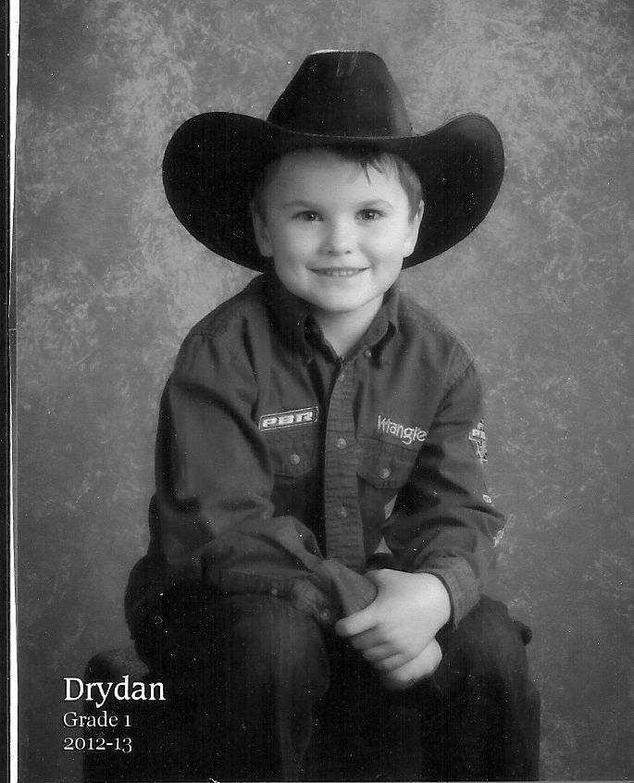
Drydan is the son of Robert and Lynette Griffith and brother to Paige, Dawson and Sheradyn. He is 6 yrs old, lives in Stockholm and is in grade 1 at Macdonald school.

Drydan loves riding his horse Reba. He belongs to the Bangor 4-H Club as well as the Melville Little Slickers. Drydan also loves animals and when he grows up would like to be an animal trainer of some kind – maybe dolphins. He also wants to be a cowboy but he really wants to be a Bull rider and his big buddy Mark Fraser has said he’ll teach him how – Look out Bull Riders!

In the winter Drydan enjoys playing hockey, defence and goalie positions are his favorite. He likes downhill skiing and ski-doing too.

Good Luck and Have Fun Drydan!

Along with the many events and activities the TVRC puts on during the year we have taken more steps to let everyone know who we are, where to finds us and what we are about. When you’re passing through Esterhazy look for our new sign, we are extremely proud of our club and the sign truly reflects that. We also have a new website www.twinvalleyridingclub.ca that we are continually updating and you can find us on Facebook too. Please check us out often and be sure to say hi!

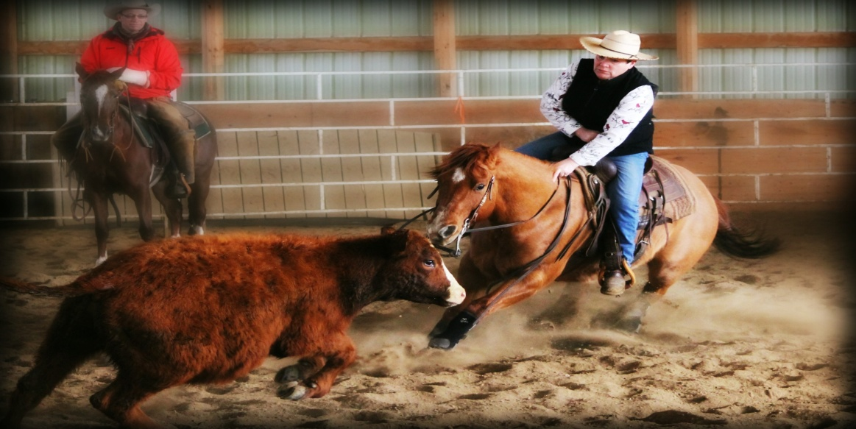
We have also started a Ride for Fun program to recognize and encourage our club members as well as anybody else that wants to participate. The program is very simple just track your riding whether it’s at home, a clinic, a competition or any organized activity. Each month someone will be selected as Rider of the Month and will receive a photo shoot with their horse and a write up recognizing their accomplishments.

For March the TVRC highlighted Laurie Cooper as Rider of the Month. Laurie is a “Lifetime Member”, to date dedicating 32 years to the Twin Valley Riding Club and that dedication shows through in her riding. Laurie works full time, boards her horses 25 minutes away from home, battled snow storms and being under the weather yet accomplished the feat of riding 24 out of 31 days, most days riding two horses and for good measure squeezed in a cutting competition. Laurie’s working buddies are Fly (Major Mito Playboy) her need for speed horse and Dude (Highbrow Dude) her sit down, hang on and work a cow horse. Laurie favors Cutting and Barrel Racing but is always pushing herself to try new disciplines, striving to learn and develop herself as a more knowledgeable and effective horseperson. The TVRC thanks Laurie for her energy and dedication to the Club and although it will be hard to meet her riding accomplishment it definitely offers an impressive goal for all of us to work towards.
Laurie Cooper – Highbrow Dude

We want to encourage everyone to get out and ride then share your adventures to really generate some excitement in the horse community.

So how about you all “Come along for the Ride”.

On June 21st & 22nd come join the TVRC in Esterhazy for the Hazy Dayz Celebration, we are all set to flip some amazing burgers at our Food Booth and show our Rider Pride in the Parade with a float and horse riders. Hazy Days Parade theme is Grey Cup in honor of Grey Cup coming to Regina this year.

Then pausing just long enough to take a deep breath, we are on to our 2nd Annual Eastside Heritage Horse Show, July 6th, 2013. A great group of organizers is doing a fantastic job to make the show even more of a success than it was last year. Some class changes have been made, appealing to a wider group of horse enthusiast. The show is dual sanctioned to include the Heritage and ManSask circuits. There are even classes to include the wonderful draft (Gypsy) horse - Draft Halter and Draft Western Pleasure. The TVRC is really excited to host this event and is looking forward to seeing you all there. Watch our Website and Facebook page for entry forms and other information.

YeeHaw! Now look out Rodeo here we come. The TVRC Bullarama and Rodeo is booked for August 24th and 25th. Look for more information on our Website, Facebook Page and the July/August issue of Show Trails.

And last but definitely not least the TVRC would like to thank the SHF for attending our Equine Extravaganza and Trade Show and providing support, information and grants to keep us on track and growing throughout the year.

Until next time “A horse doesn’t care how much you know until he knows how much you care”.

